|  |  |  |  |  |  |
| --- | --- | --- | --- | --- | --- |
| **INDUSTRIAL VISITS** | | | | | |
| **S.No** | **Session** | **Date Of Visit** | **Name of Industry Visited** | **No of students Participated** |
| 1 | 2023-24 | 03 November, 2023 | Akshat Autoline Private Ltd, Meerut | 60 |
| 2 | 14 December,2023 | Deki Electronics, Noida | 56 |
| 3 | 02 February, 2024 | VVDN Technologies Pvt Ltd, Gurugram | 50 |
| 4 | 2022-23 | 28 September,2022 | Deki Electronics, Noida | 52 |
| 5 | 30 September,2022 | Akshat Autoline Private Ltd , Meerut | 56 |
| 6 | 21 March ,2023 | Bisleri International Pvt Ltd | 55 |
| 7 | 22, March,2023 | CFEES, cluster of DRDO | 55 |
| 8 | 2021-22 | 22 April ,2022 | CSIR National Laboratory,New Delhi | 43 |
| 9 | 2019-20 | 9 August , 2019 | Inter University Accelerator Centre | 50 |
| 10 | 14 August , 2019 | Bisleri International Pvt Ltd | 50 |
| 11 | 18 September , 2019 | Solid State Physics Lab, Ministry of Defence DRDO | 55 |
| 12 | 07 Feburary, 2020 | Deki Electronics, Noida | 55 |
| 13 | 04 March,2020 | Automation Engineers AEAB Pvt. Ltd, Noida | 50 |
| 14 | 2018-19 | 27-Sep,2018 | Automation Engineers AEAB Pvt. Ltd, Noida | 70 |
| 15 | 30 January, 2019 | Sofcon India Pvt. Ltd., Noida (2nd Year, Sec-B) | 65 |
| 16 | 31 January, 2019 | Sofcon India Pvt. Ltd., Noida (3rd Year, Sec-D) | 57 |
| 17 | 5 February, 2019 | IETF-2019 organized by Confederation of Indian Industries (CII) at Pragati Maidan, New Delhi | 80 |



Akshat Autoline Pvt. Ltd, Meerut

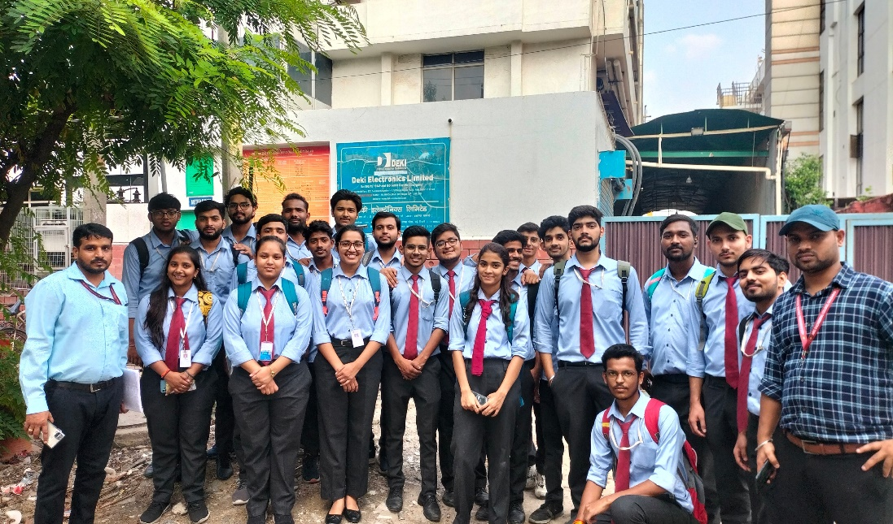

Deki Electronics Private Ltd. Sector 58,Noida

VVDN Technologies Pvt. Limited, Gurugram

**Association With**

